
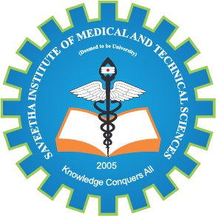
SIMATS ENGINEERING

Saveetha Institute of Medical and Technical Sciences Chennai- 602105
Student Name: HARINI S Reg. No: 192511153
Course Code: CSA0511 Slot: B
Course Name: DATABASE MANAGEMENT SYSTEM FOR DATA SCIENCE
Course Faculty: Dr.K.SASHI REKHA
Project Title: EXPENSE TRACKER
Module Photographs:
 | 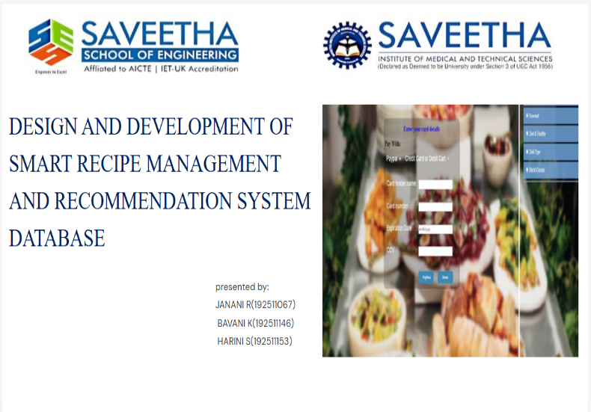 | 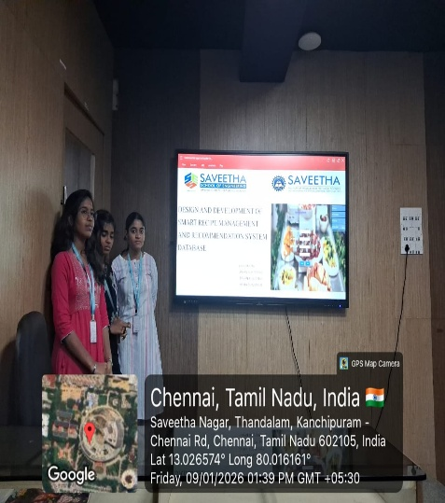

Project Description:
The “Design and Development of a Smart Recipe Management and Recommendation System Database” project focuses on creating a structured database system to store, manage, and retrieve recipe-related information efficiently. The system maintains details such as recipes, ingredients, nutritional values, user preferences, and cooking methods in a well-organized relational database. It also supports smart recommendation features that suggest recipes based on available ingredients, dietary preferences, and user interests.

This project demonstrates the practical application of Database Management Systems (DBMS) concepts including table design, relationships, constraints, and SQL queries to enable fast searching, filtering, and personalized recipe recommendations. The system aims to reduce manual effort, improve data accuracy, and enhance the user experience by providing an intelligent and user-friendly recipe management solution.

Student Signature Guide Signature

